**The Provincetown Players (1915-1922)**

Founded in Provincetown, Massachusetts in 1915 and transplanted to Greenwich Village in 1916, the Provincetown Players was one of the most influential theatrical organizations in American theatre history. Their membership was a veritable who’s who of the era’s leading political and cultural revolutionaries, including its *spiritus rector,* socialist writer George Cram (Jig) Cook; post-impressionist artists William and Marguerite Zorach and Bror Nordfeldt; labor journalists John Reed and Mary Heaton Vorse; modernist poets Wallace Stevens, Alfred Kreymborg, Mina Loy, and Edna St. Vincent Millay; New Stagecraft pioneers Robert Edmond Jones and Cleon Throckmorton; and more than fifty playwrights whose dramaturgical innovations defied contemporary critical description.

In addition to formal experimentation, Provincetown playwrights were noted for their frank treatment of such topical issues as racial, ethnic, and religious Otherness, class conflict, war, and changing gender and sexual mores. Their plays manifested the most current trends in the era’s intellectual discourse: Freudian and Jungian psychology; Nietzschean challenges to traditional morality; Havelock Ellis and Ellen Keys’s ideas on egalitarian sexual and marital relationships; the social theories of Karl Marx and Edward Carpenter; the feminism of Emma Goldman, Margaret Sanger, and Crystal Eastman; and the parenting techniques of Maria Montessori. Provincetown’s notable works include a number of witty, reflexive, and meta-theatrical satires of contemporary Village life, including Susan Glaspell and Jig Cook’s *Suppressed Desires,* John Reed’s *The Eternal Quadrangle,* Neith Boyce’s *Constancy* and *Enemies*, Floyd Dell’s *Sweet and Twenty*, and Wilbur Daniel Steele’s *Not Smart*. Sometimes the reflexive topicality was delivered in a sharper tone, as in Steele’s *Contemporaries,* Glaspell’s *The Verge,* and Pendleton King’s *Cocaine*.

From the pens of poet-playwrights came proto-absurdist whimsies with lurking subtextual profundities on the human condition: Millay’s *Aria Da Capo*, Kreymborg’s *Lima Beans*, Djuna Barnes’s *Three From The Earth*, and Maxwell Bodenheim’s *The Gentle Furniture Shop*. Glaspell led a vanguard of feminist playwrights who made Provincetown’s stage a platform for some of the era’s most provocative dramatizations of women’s discontent under patriarchy, including Glaspell’s *Trifles*, *Woman’s Honor*, and *Chains of Dew*, Neith Boyce’s *Winter’s Night*, Rita Wellman’s *Funiculi-Funicula*, Evelyn Scott’s *Love*, Edna Ferber’s *The Eldest,* and Alice Rostetter’s *The Widow’s Veil*. The Players introduced the plays of Eugene O’Neill, including his haunting and lyrical Glencairn cycle, the Jungian-inspired *Emperor Jones*, and the expressionist working-class parable *The Hairy Ape*.

Dramaturgical experiments led to corresponding innovation in performance and scenic practices. The Players pioneered selective realism in stage settings, as well as abstract, Bakst-inspired scenery, expressionist visualization of the subconscious, and the use of masks. The Players were the first company in America to install a curved plaster cyclorama, a device that allowed for such amazing lighting effects that audiences demanded encores.

By 1920 some of the Provincetowners, like O’Neill and designer Robert Edmond Jones, had achieved a significant measure of commercial success and were clamoring for more professional methods of operation. Beset by artistic and personal differences within and by a conservative backlash in the cultural arena in the aftermath of World War I, the Players’ community of like-minded bohemian rebels began to disintegrate. They ceased operation in 1922. Cook and Glaspell departed for Greece, and a number of other important members joined the expatriate community in Paris. The Provincetown experiments in modernist aesthetics were reinvigorated two years later, however, when O’Neill, Jones, critic Kenneth Macgowan, and several former Provincetowners resumed operations as The Experimental Theatre, Inc., at the Players’ MacDougal Street space. Here O’Neill and Jones, along with the similarly adventurous e. e. cummings, Edmund Wilson, and Stark Young, carried on the Provincetown traditions of presenting provocative content in strikingly original and anti-realist styles. Other Provincetown artists found homes in the burgeoning workers’ theatre movement, the Federal Theatre Project, regional and educational theatres, and the mainstream commercial theatre, ensuring both the pervasiveness and longevity of the Provincetown legacy.

**References and Further Reading**

Black, Cheryl. (2002) *The Women of Provincetown, 1915-1922*, Tuscaloosa: University of Alabama Press.

Egan, Leona Rust. (1994) *Provincetown as a Stage: Provincetown, the Provincetown Players, and the Discovery of Eugene O’Neill,* Orleans, MA: Parnassus Imprints.

Murphy, Brenda. (2005) *The Provincetown Players and the Culture of Modernity*, Cambridge: Cambridge University Press.

Ozieblo, Barbara, ed. (1994) *The Provincetown Players: A Choice of the Shorter Works*, Sheffield: Sheffield Academic Press.

Sarlós, Robert Károly. (1982) *Jig Cook and the Provincetown Players: Theatre in Ferment,* Amherst: University of Massachusetts Press.

<http://www.provincetownplayhouse.com/home.html>

<http://www.eoneill.com/>

<http://www.eugeneoneillsociety.org/>

<http://blogs.shu.edu/glaspellsociety/>

**Cheryl Black, University of Missouri**

**Recommended Illustrations**

[use all if possible, but if that’s not possible, the illustrations are listed in descending order of preference]

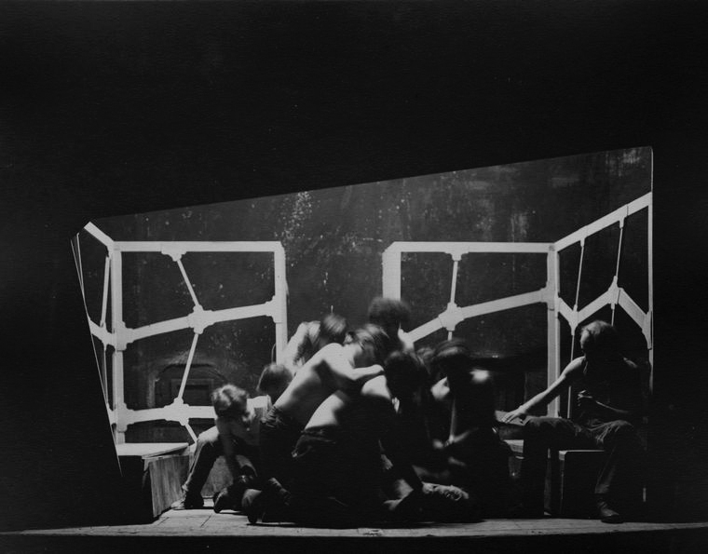

**Eugene O’Neill’s *The Hairy Ape,* 1922, designed by Robert Edmond Jones and Cleon Throckmorton.**

**(Billy Rose Theatre Collection, New York Public Library).**

[Available at NYPL Digital Gallery, Image ID: 1101521]

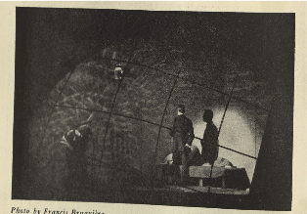

**Susan Glaspell’s *The Verge,* 1921, designed by Cleon Throckmorton.**

**(Billy Rose Theatre Collection, New York Public Library).**

[Available at: <http://digitalgallery.nypl.org/nypldigital/dgkeysearchresult.cfm?keyword=susan+glaspell&submit.x=4&submit.y=6.>]

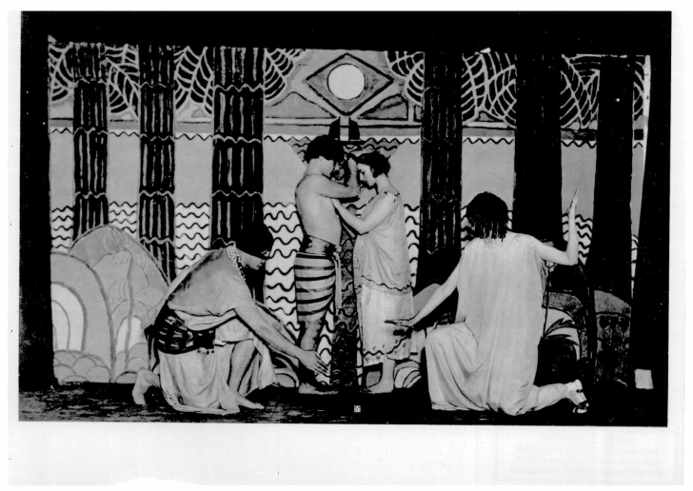

**Louise Bryant’s *The Game*, 1916, designed by Marguerite and William Zorach.**

(Source: Harvand Theatre Collection)

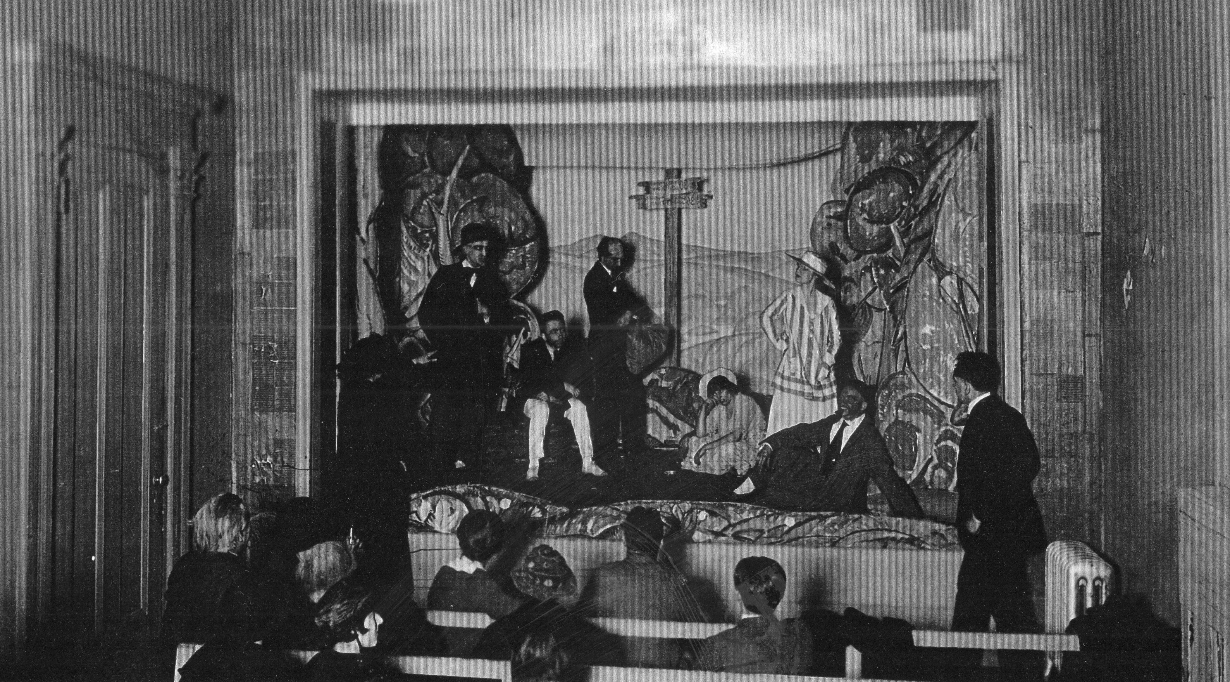

**David Pinski’s *A Dollar,* 1917, designed by Bror Nordfeldt.**

[Source: Brown Bros, Sterling, PA.<http://www.brownbrothersusa.com/>

Phone: (570) 689-9688

Fax: (570) 689-7873

E-mail:info@brownbrothersusa.com

Post: 100 Bortree Road, P.O. Box 50, Sterling, PA, 18463-0050, USA]